**Learning Journal**

**14/02/2023**

11:37

Issue:

For my BehaviourSwitch script, which at the time was called GhostSwitch, I was using SetActive() to enable and disable the different components/behaviours such as the character controllers and cameras in the script itself.

11:10 - Solution:

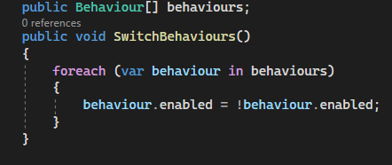

Instead of using SetActive() over and over again in the script, I ended up creating a for loop that enables and disables certain behaviours that are put into it. By being able to switch the behaviours that can be assigned and changed at any time in the inspector, the script became much more versatile and reusable.

**21/02/2023**

10:27

Issue:

Using InvokeRepeating to put a cooldown on the slingshot ability doesn’t work.

10:54 - Solution:

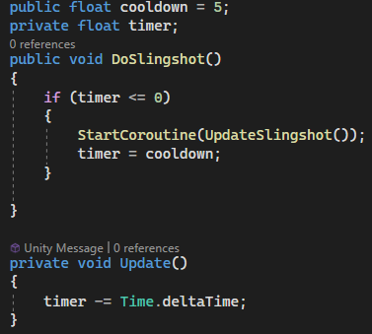

I made a timer and a cooldown variable. I set the cooldown to 5 and made the timer count down constantly, and I’m only able to execute my code when the timer goes down to zero or less. Every time the ability is used the timer goes back to 5.

**28/02/2023**

10:53

Issue:

My movement wasn’t working, because I wasn’t declaring how I make my character move, which is using GetAxis.

12:12 - Solution:

I’m using GetAxis to move and then characterController.Move to make my character faster or slower (depending on what I want to achieve with this) whenever I’m going through a wall.

**07/03/2023**

10:54

Issue:

My character is going up to a certain point but isn’t climbing the ledge.

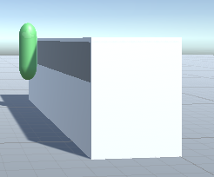

11:20 - Solution

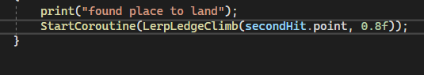

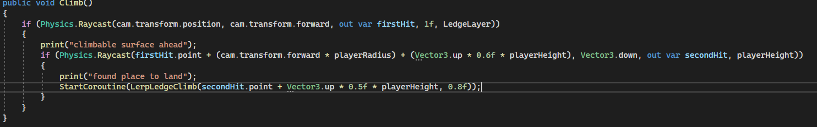

The problem was that on secondHit I was shooting an array cast down equal to the player height, but because the pivot point of my player is in the middle of its body, not at its feet I had to add half the player’s height to the point I wanted to move to.